NEW hire task
1 – setup window
2 – setup printer account
3 – Outlook (zoom)
4 – default web browser (Chrome)
5 – shortcut to Unikey to Desktop
6 – MSteam.
7 – Setup Okta Verify

Network
Subnet HCM: 10.54.218.0/24 (wired ) , 10.54.219.0/24 (wireless)
HN: 10.54.222.0/24(Wired) , 10.54.223.0/24(wireless)

Printer Settup (web access work only with IE mode)
11111/x-admin (admin account)
http://10.54.218.170/ B&W printer HCM , 32 Floor
http://10.54.218.171/ Color Printer HCM , 32 Floor
http://10.54.218.17/ Color Printer HCM , 24 Floor
http://10.54.222.171/ Color Printer HN

Setup Printer on colleague machine :
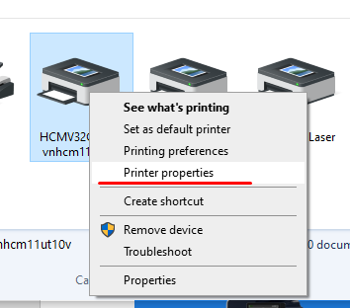

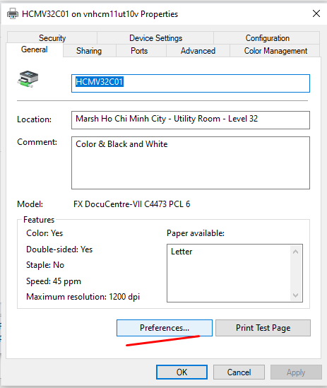
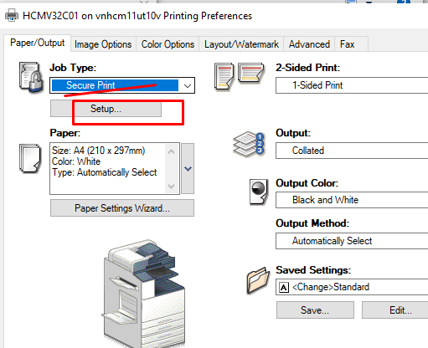

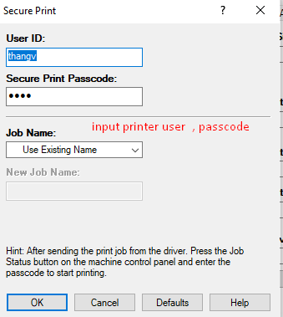

Fix Vietnamese font (Ư, Ơ)
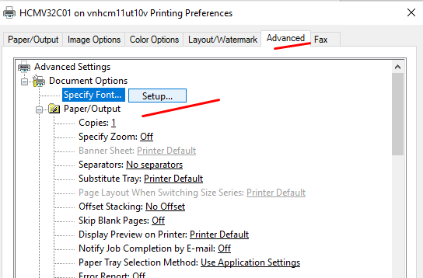

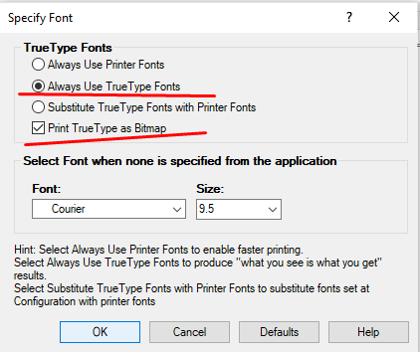

select Properties -> Security -> Authentication Configuration -> next -> input number -> setup user info -> save -> done
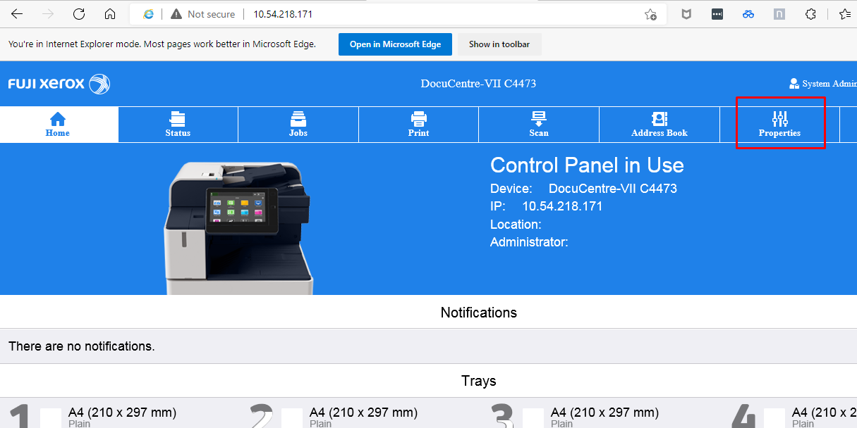

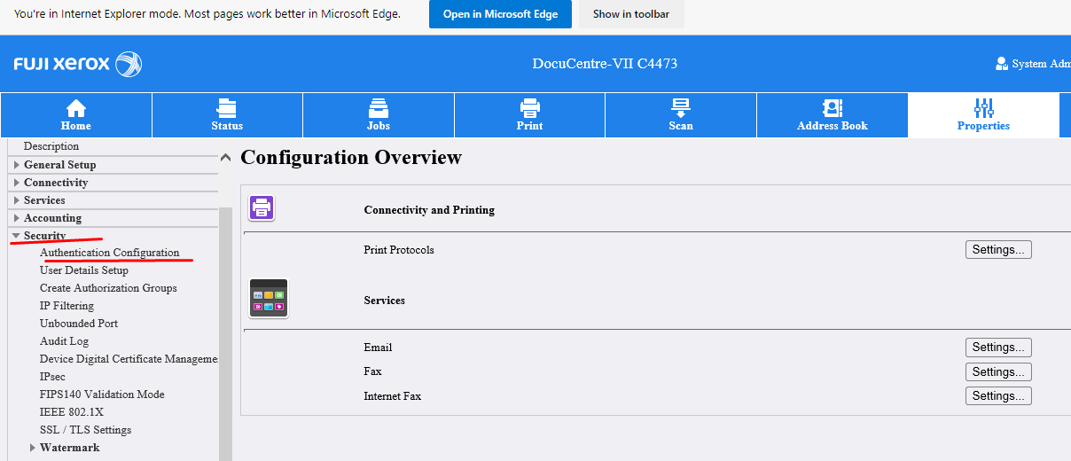
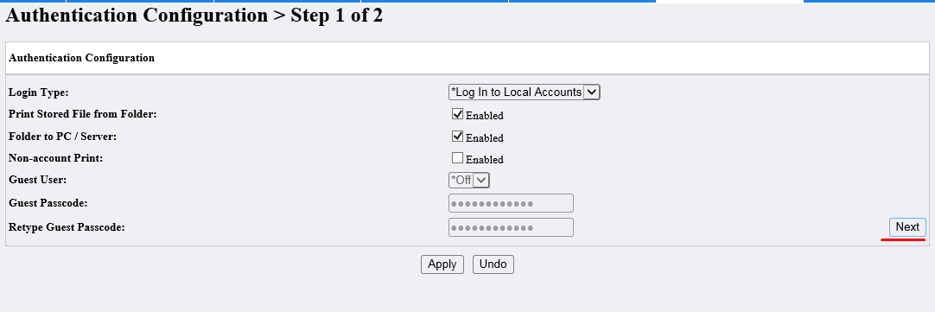

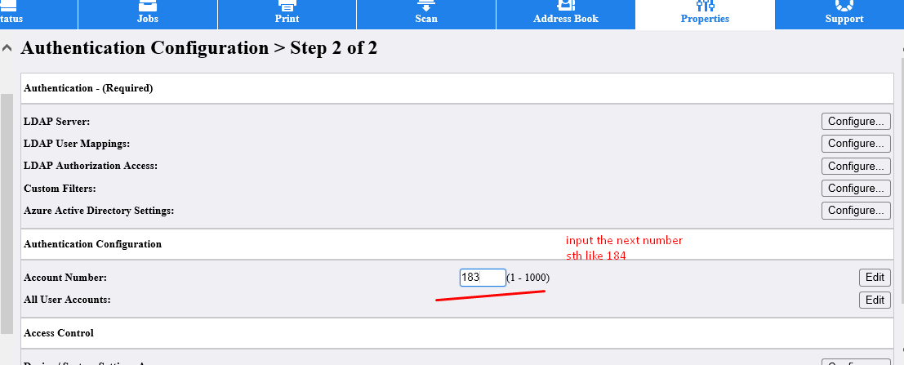

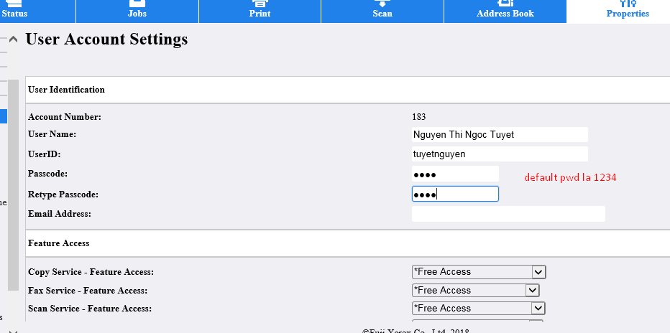
Create guest account (Wifi V2)
https://usdal1-03cp01.us.mrshmc.com/guest/auth_login.php?target=%2Fguest%2Fcreate_user.php

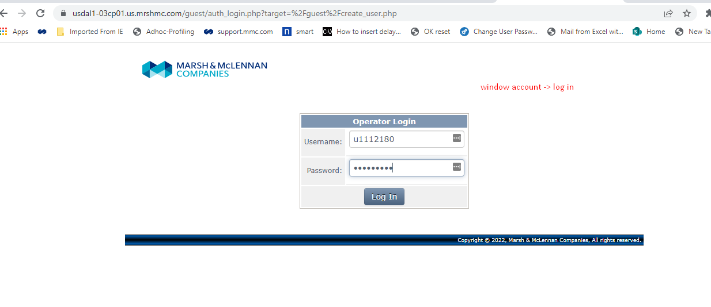

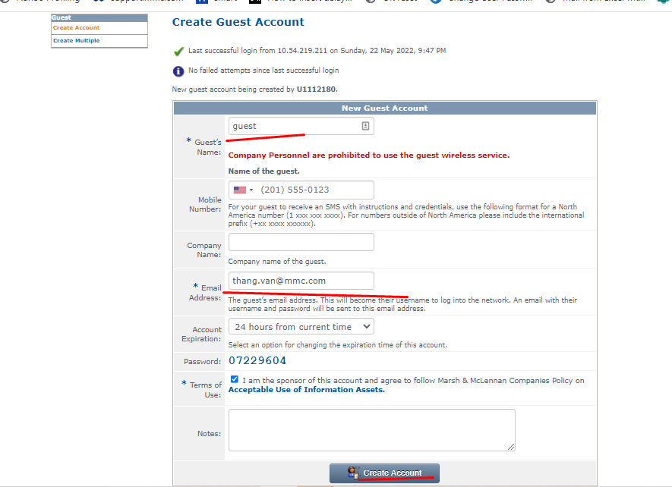

Phone setup
842301/P@ssword
https://10.52.38.15/ccmadmin/showHome.do

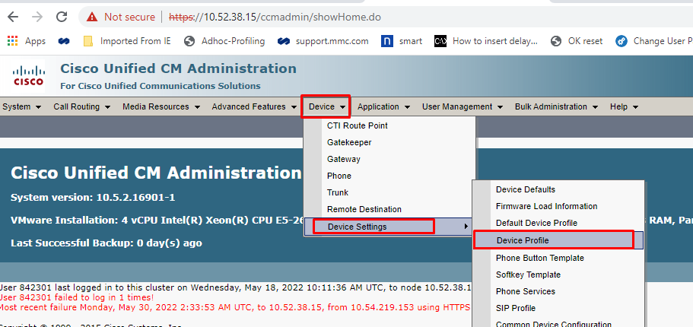

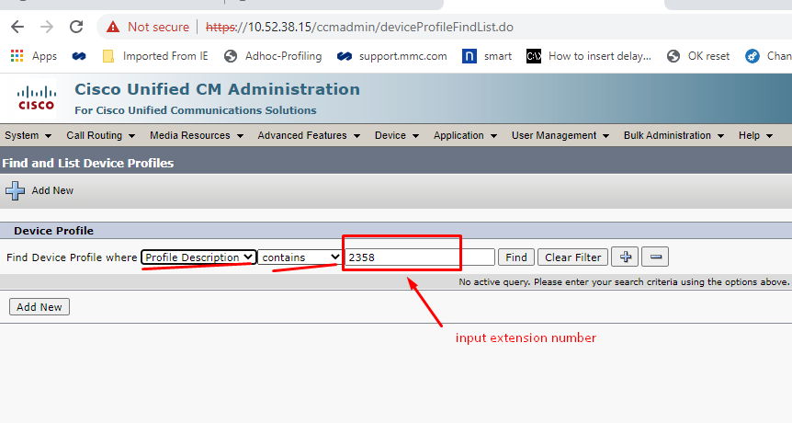

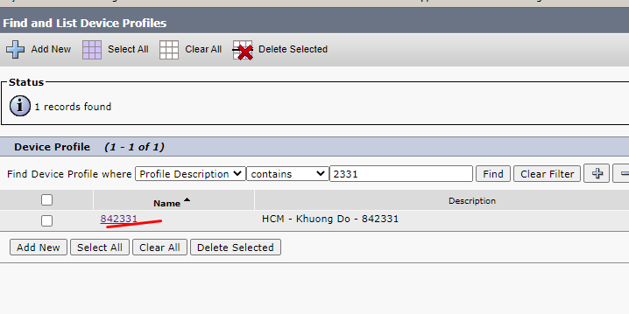

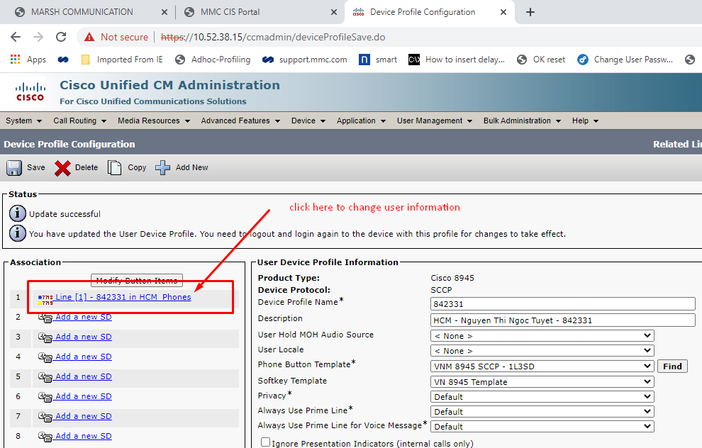
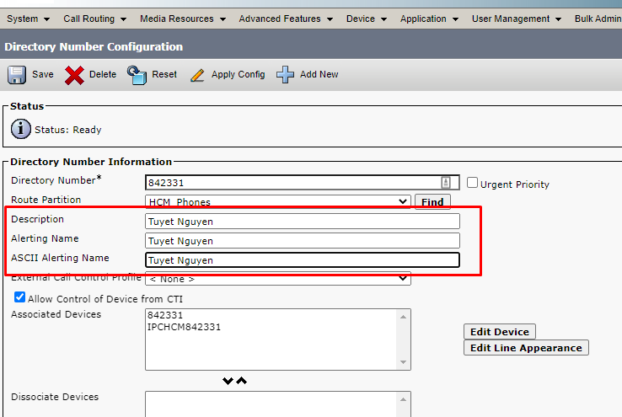
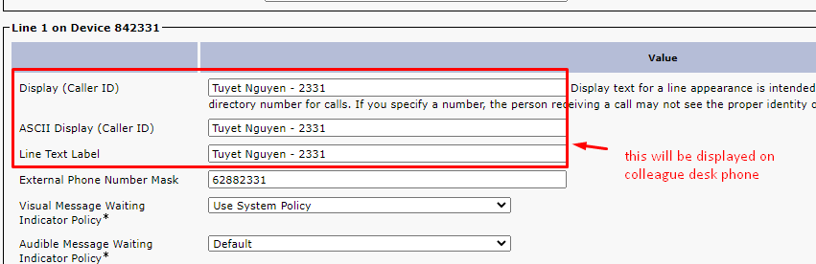

Service Now
10 Nexthin tickets per month (ticket subject include “Nexthink” )
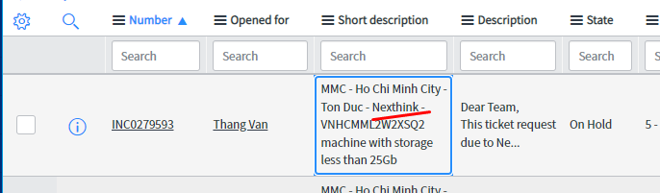
15 tickets per weeks
https://mmcnow.service-now.com/nav_to.do?uri=%2Fhome_splash.do%3Fsysparm_direct%3Dtrue

Create Favorite Queue

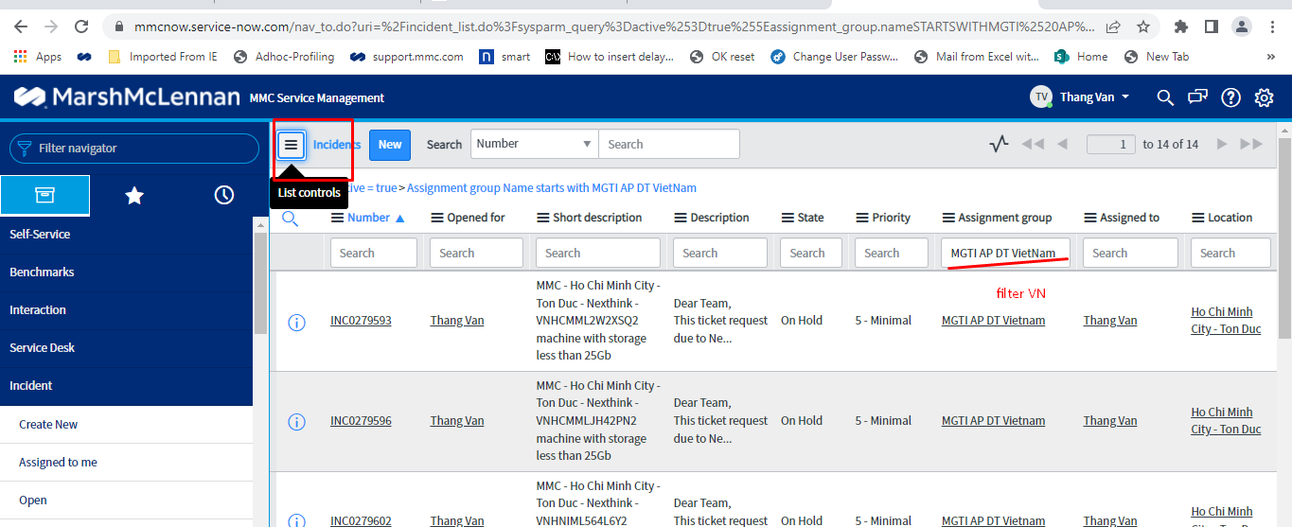

FALCO

CCTV
-CAM nhu (192.168.0.101 (admin/abcd1234) (Hikvision)
- Cam local Marsh (10.54.218.3 – 24 Floor , 10.54.218.200 – 32 Floor - User login (admin/admin)

Software : Avtech (Viewer) , Hivision CMS

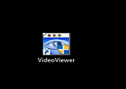
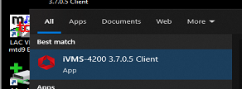

MDE password forgotten
https://epo.mmc.com:58443/core/orionSplashScreen.do
log on corp\normal account

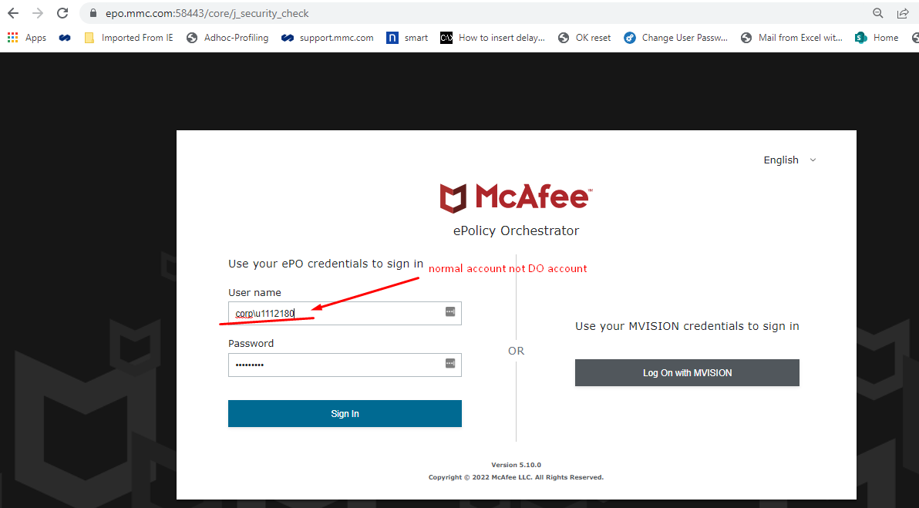

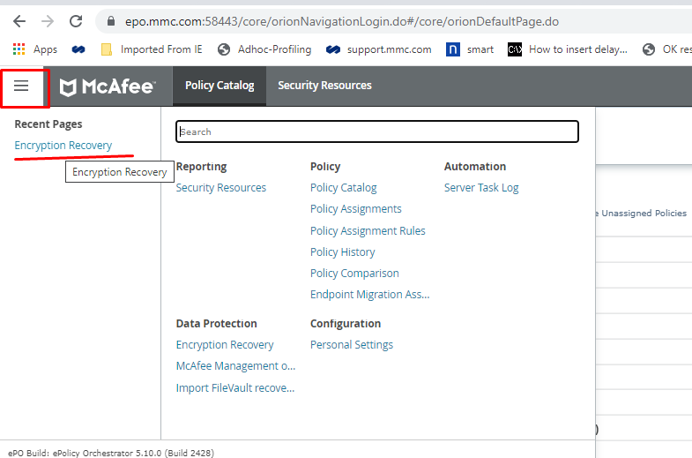

Ask colleague to provide Client code

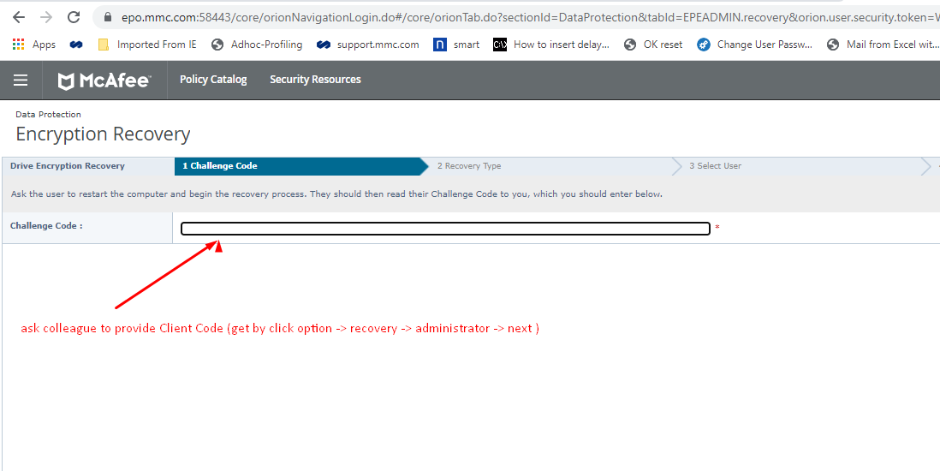

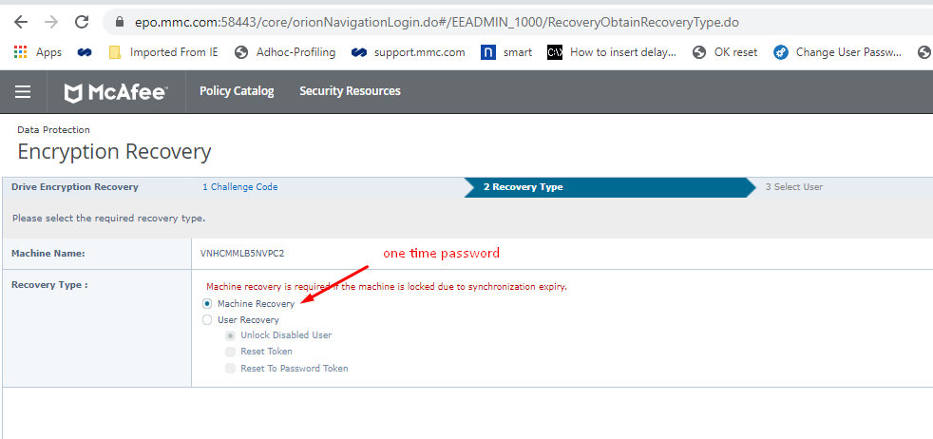

Provide the code to client
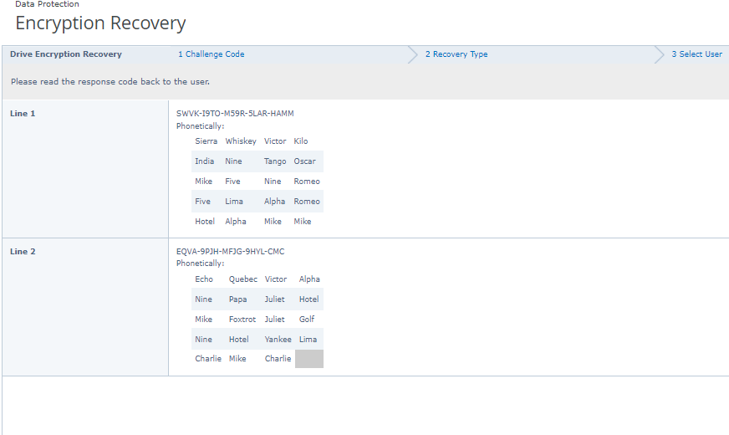

OKverify reset
https://mgticoad.mgd.mrshmc.com/OKTAServiceDesk/
log on = do account
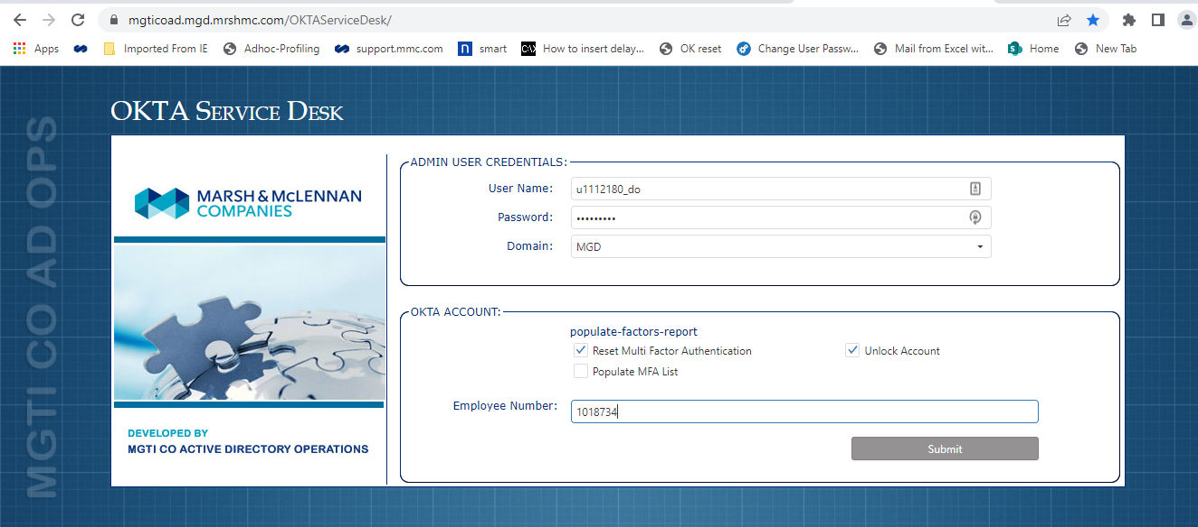

Okta link
https://mmcglobal.okta.com/enduser/settings

BYOD removal
https://na2.mobileiron.com/user
input email address -> login
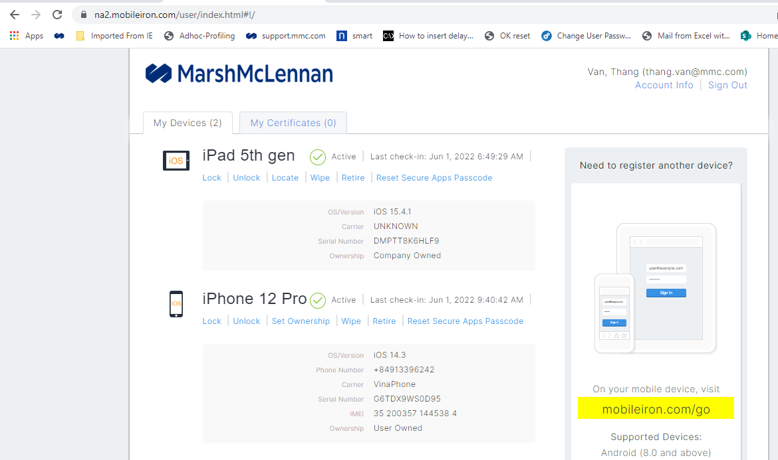
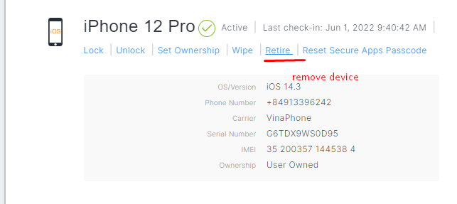
submit mytime shift
https://mmc.pvcloud.com/planview

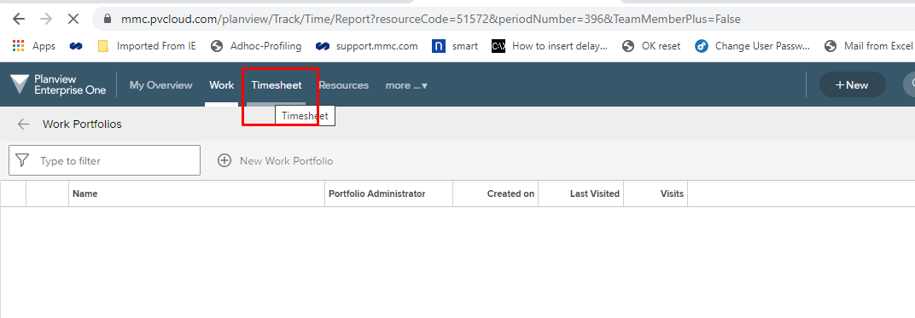

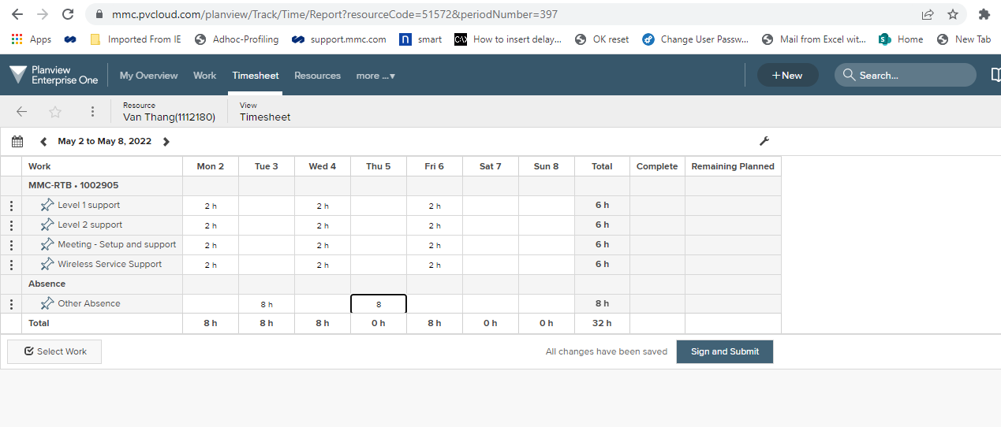

Update GPO
Using MGTIexplorer

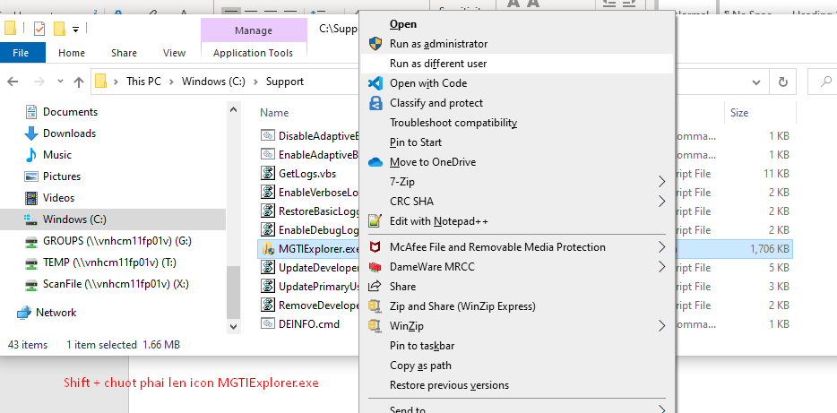

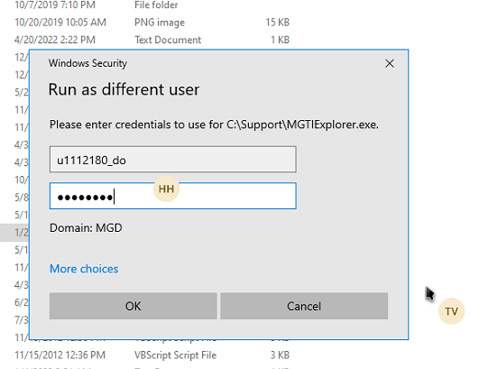

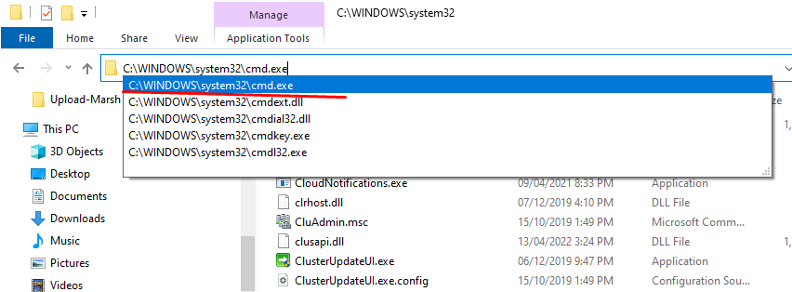

Gpupdate /force

Purchase / Receive
Mua thiet bi:
- Get bao gia tu vendor
- Get MGTI approval from Nanthid
- Raise procurement (https://financesolutions.mmc.com )
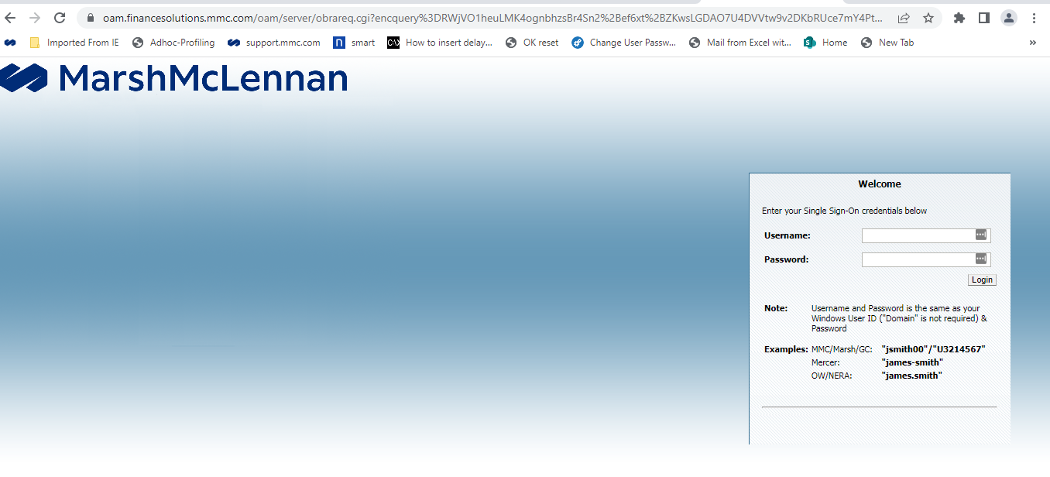
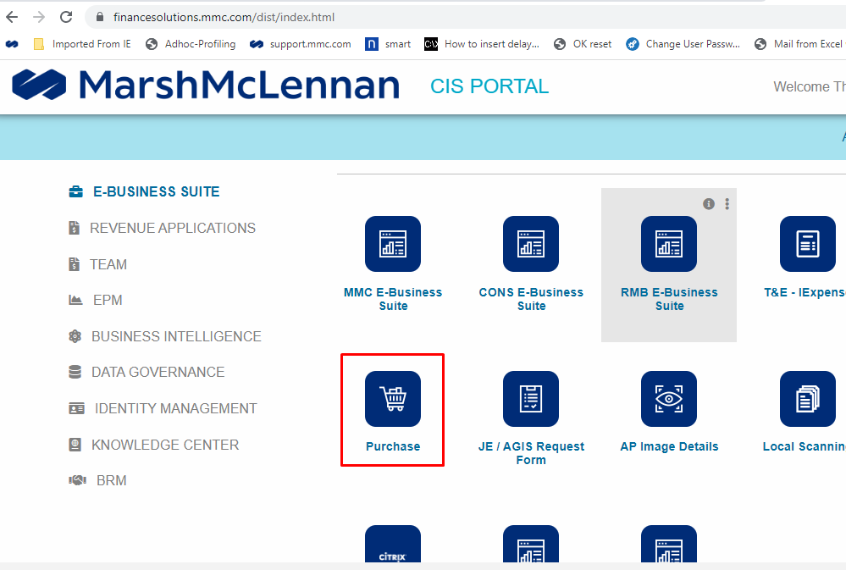

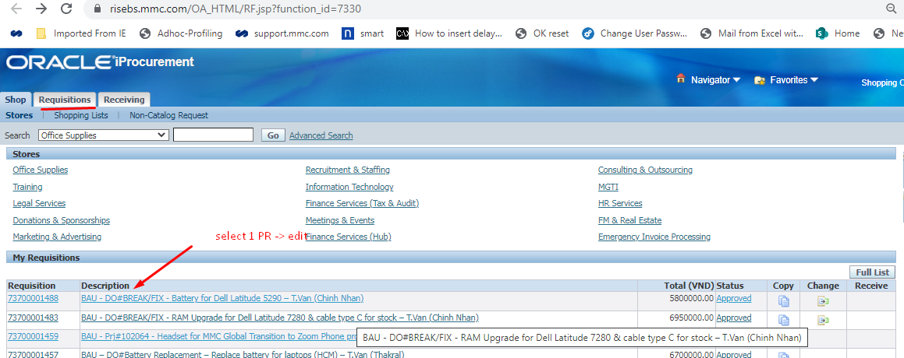
copy to cart

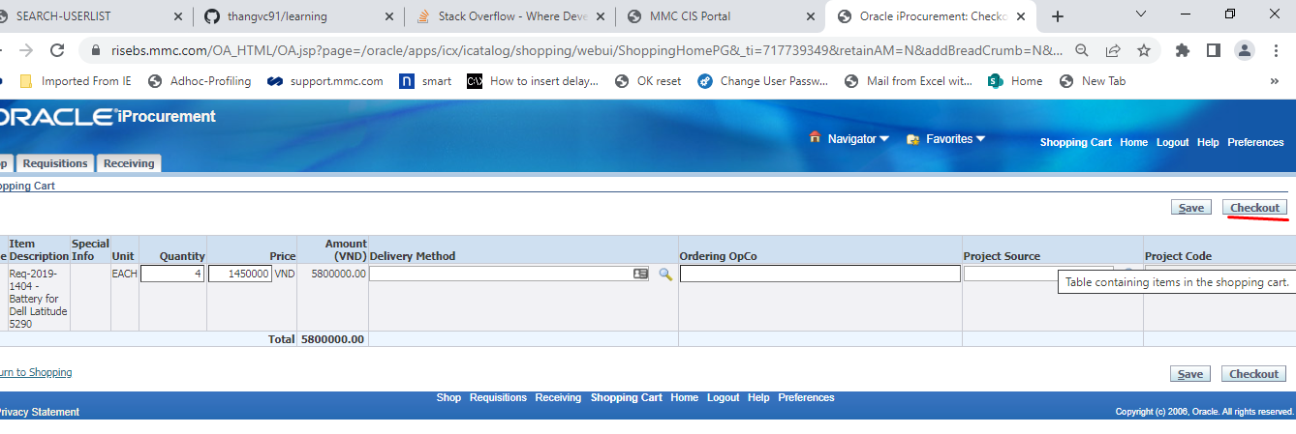

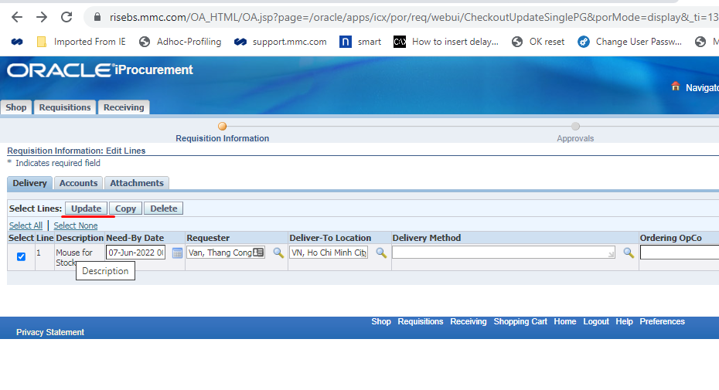

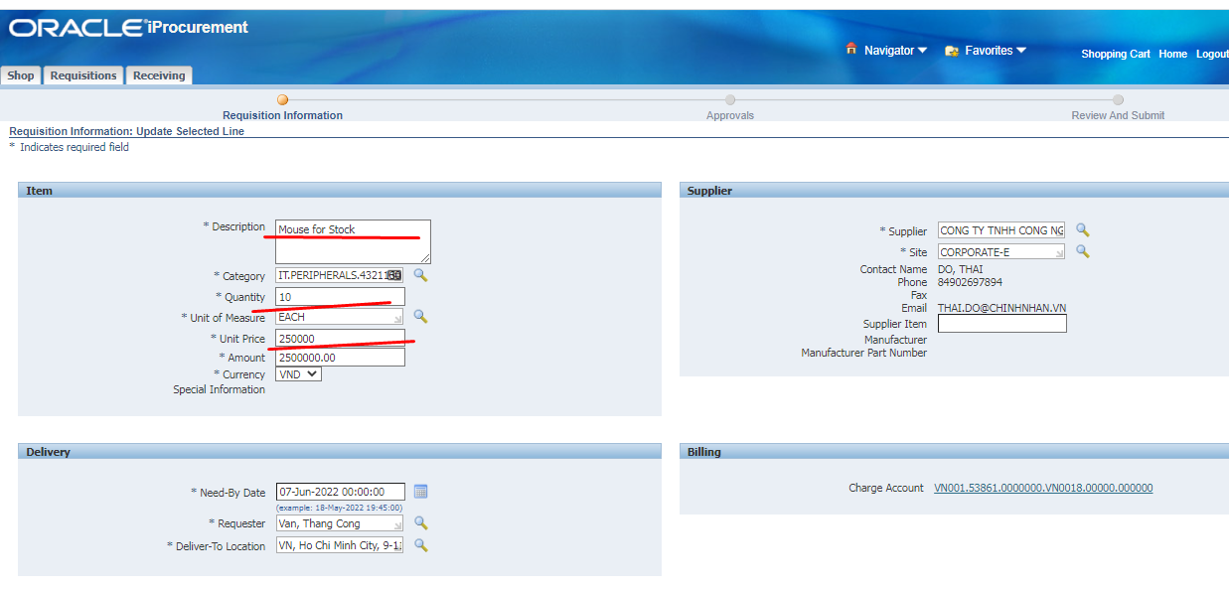

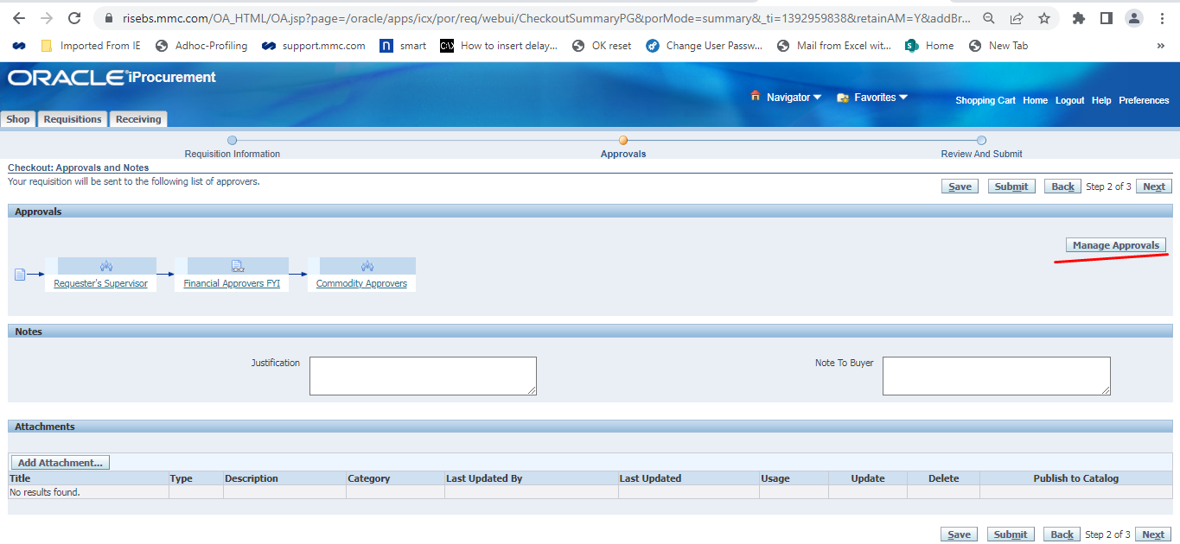
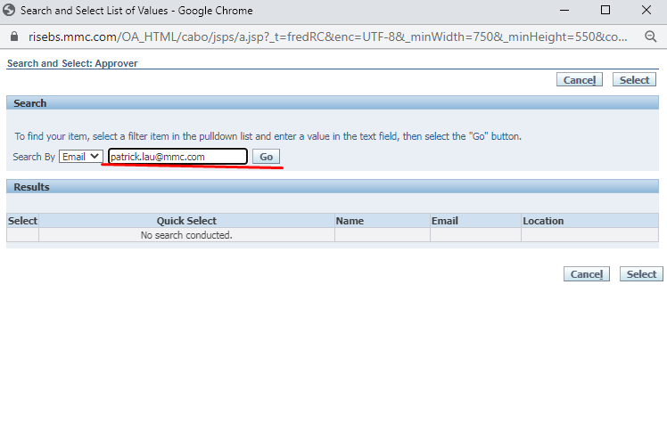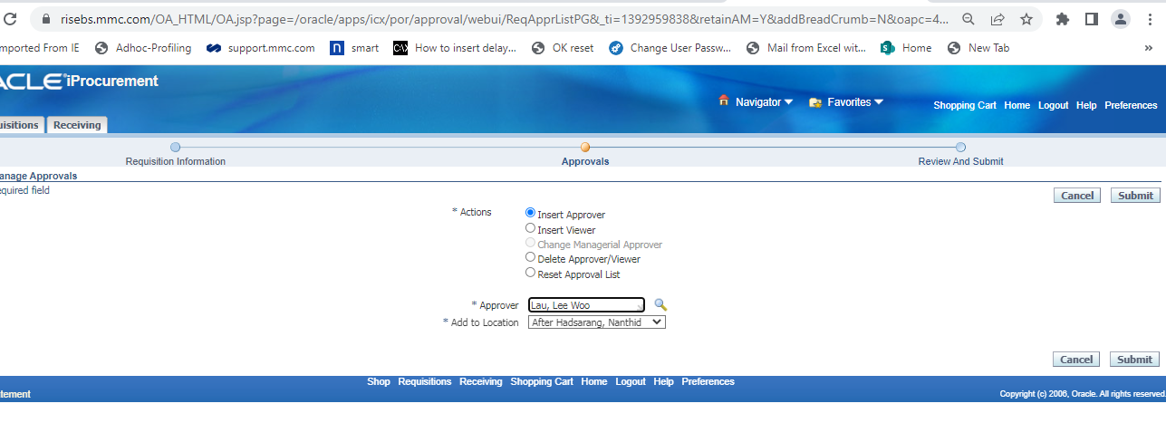
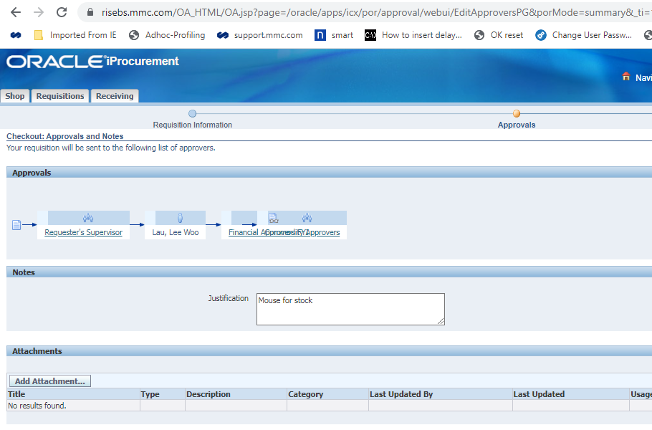
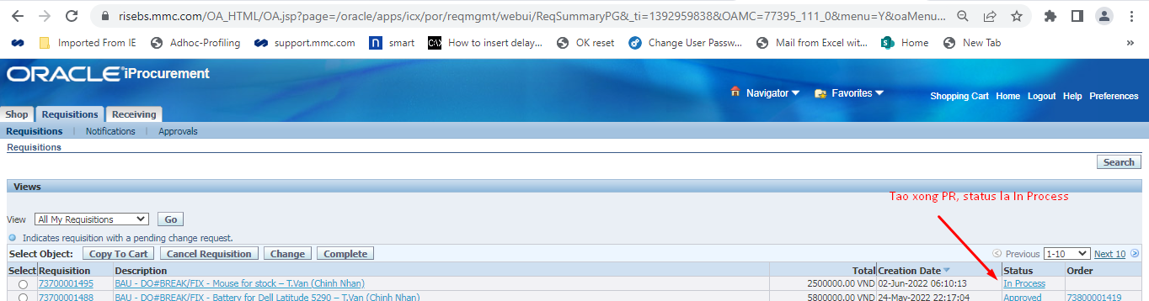

Vendor contact:
1 – Chinh Nhan (IT accessories (mouse, RAM, adapter …) : phong.dung@chinhnhan.vn <phong.dung@chinhnhan.vn>
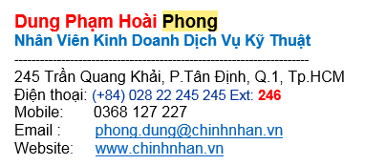
2 – Thakral (IT accessories): lien.huynhthikim@thakralvn.com
3 – Vietnet (FALCO, M&E vendor): tan@vietnet.net.vn

